Brief ConveyTM

LOTR Transparency Declarations

Quick Reference Guide

Quick
Reference
Guide

November 2020

Brief Convey LOTR Transparency Declarations
Quick Reference Guide

Required filings to the Land Owner Transparency Registry (LOTR) begin on November 30th, 2020. Visit the Land Transparency website for complete details.

To save you time, we have added the ability to create Transparency Declarations directly through Brief Convey. The creation of Transparency Declarations is similar to the creation of LTSA Web Forms that are currently available in Brief Convey.

LOTR Tab
All Purchase file matters have a LOTR tab available. This tab is used to create Transparency Declarations at myLTSA.

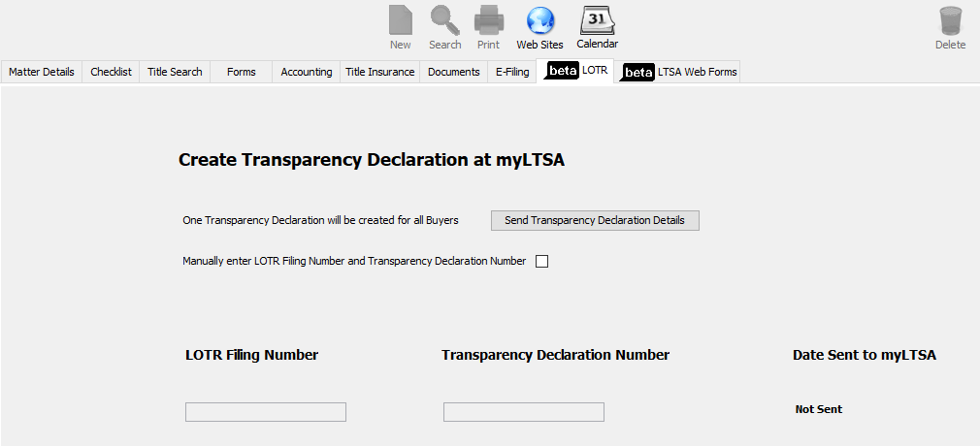

Each time the Send Transparency Declaration Details button is clicked, one Transparency Declaration will be created at myLTSA that will include all purchasers and all PIDs entered in your file matter.

When the Transparency Declaration is successfully created on myLTSA, the LOTR Filing Number, Transparency Declaration Number, and Date Sent to myLTSA will populate on the LOTR tab.

If you will be using Brief Convey’s E-filing feature and your Transparency Declaration was created outside of Brief Convey, select the Manually enter LOTR Filing Number and Transparency Declaration Number checkbox to enter the numbers.

Note: Transparency Reports must be created directly at myLTSA.

Creating a Transparency Declaration
When the Send Transparency Declaration Details button on the Tab is selected, Brief Convey will send the available information to myLTSA to create and populate a LOTR Transparency Declaration:

Transparency Declaration
Section of Transparency Declaration | Data from Brief Convey File
Create Record/Property Information | The first 30 characters of the Brief Convey file number  All PIDs from the Properties tab
Transferees | Name(s) of individual purchasers  Is this transferee a reporting body will populate with ‘No’  Name(s) of corporate purchasers  Is this transferee a reporting body will not populate – this information must be completed directly at myLTSA
Certifier Information | Name(s) of individual purchasers  No information will populate for corporate purchasers – this information must be completed directly at myLTSA

View Transparency Declaration on myLTSA
When Brief Convey successfully creates a Transparency Declaration at myLTSA, you will see the following message:
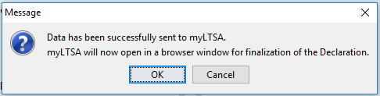
Click OK to have myLTSA open in a browser window. If you are already logged in to myLTSA outside of Brief Convey, the browser window will open to the Transparency Declaration. If you are not already logged in to myLTSA, the browser window will open to the myLTSA login page. Once logged in you will then be moved to the Transparency Declaration.

Completing the Transparency Declaration at myLTSA
Finalizing any additional data entry, printing, truing up, validating, affixing a digital signature, and paying the filing fees will all be done directly on myLTSA.

For support on any of these features, please contact LTSA Customer Service at 604.630.9630 or 1.877.577.5872 or customerservice@ltsa.ca.

E-filing
The Transparency Declaration Number is required for e-filing a package that includes an application to register an interest in land. When using the Brief Convey e-filing feature, the required LOTR filing number as entered on the LOTR tab will automatically be submitted with the Form A Freehold Transfer in the e-filing package.

Note: If you are registering an interest in land with a document other than the Form A Freehold Transfer, you must submit your e-filing package directly at myLTSA.

If a LOTR filing number is required and one is not populated on the Brief Convey LOTR tab, or the Transparency Declaration has not been digitally signed and the filing fees paid, LTSA will return an error message which will be displayed to you and your package will not be filed. Once all items noted in the error message are resolved you can submit your package again.

For support on e-filing outside of Brief Convey, please contact LTSA Customer Service at 604.630.9630 or 1.877.577.5872 or customerservice@ltsa.ca

Need Help?
If you require further assistance, please contact customer service at 1.866.367.7648 or inquiries@doprocess.com.

